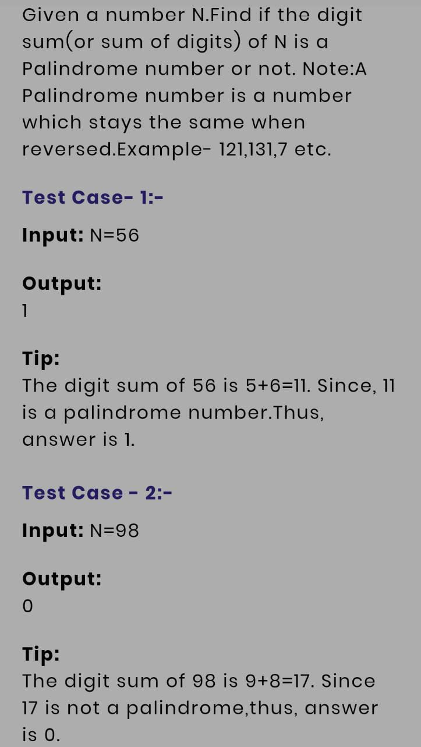

import java.util.\*;

public class Main

{

public static void main(String[] args) {

Scanner sc=new Scanner(System.in);

String str=sc.nextLine();

int sum=0;

for(int i=0;i<str.length();i++){

sum+=Character.getNumericValue(str.charAt(i));

}

String a=String.valueOf(sum);

StringBuilder b=new StringBuilder(a);

String c=b.reverse().toString();

if(a.equals(c)){

System.out.print("1");

}

else{

System.out.print("0");

}

}

}